We have had a very busy start to the year. Here are a few highlights.  Ofsted Visit  On Wednesday 25th and Thursday 26th January we welcomed Ofsted inspectors to school. The overall judgement will be shared when the report is finalised. I would just like to thank and praise all the children and staff for their phenomenal effort, not just during the inspection, but every day they come to school.  Attendance  We are really pleased that a number of children have received a 100% attendance certificate last half term. Attendance has really improved during the Spring Term with 96.3% for the whole school and we look forward to seeing this improve further.  Councillor Visits  We have had several visits this half term from our local councillors. Councillors Ready, Flynn and Conway have been in to award children with a special commemorative Wigan Warriors medal and to provide the children with some money to improve our school. The school council are currently deciding how to best use the money.  Year 6-Edge Hill Experience  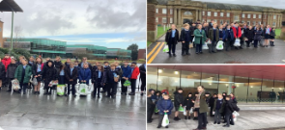  Our Year 6 children attended Edge Hill University as part of our Trust Family. They had a range of experiences and learned what further education has to offer them.  Playground markings  Our School Council and Year 6 children have worked alongside Shona from ESP to design and cost the new markings for the playground. The final design has been completed and will soon be installed. A new pitch and fitness circuit are some of the highlights.  Scarf-Life Caravan  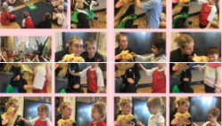  We welcomed the team from SCARF in to school on Tuesday 31st January. They delivered a range of sessions to children about healthy lifestyles and keeping themselves safe.  Charitable Collections  We raised a fantastic £82 for NSPCC and £34 for Young Minds as part of Children’s Mental Health week. We have also raised a staggering £135 for the Syria and Turkey Earthquake appeal. | Dinosaur Day  Our Acorn Class had a wonderful experience alongside the children from Canon Sharples where they met a life-size dinosaur. The children were learning about Dangerous Dinosaurs and this experience really brought it to life for them.  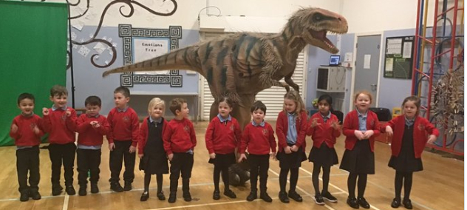  Friends of St David’s  Thank you very much to the Friends of St David’s for organising presents for the children to celebrate Chinese New Year. They have also provided the Reception with new bark for their playground and ran a very successful ‘Hot Dog Friday’.  Swimming Gala  Well done to all our children who competed at the Aspull School’s swimming gala on Thursday 16th February. They all tried really hard and did themselves and the school really proud.  Love Your Community Week  We celebrated our local community by coming together with Aspull Church and Our Lady’s Primary Schools for a service at St David’s Church. There was some fantastic singing and individual performances. We also completed a litter pick at Haigh Hall, supported by Councillors Ready and Conway.  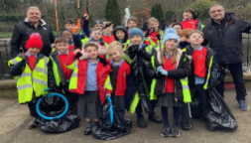  Safer Internet Day-Tuesday 7th February  It is really important that our children know how to use the internet safely and keep themselves safe. We used a range of texts to explore the potential dangers of the internet.  Important Dates  Friday 17th March-Non Uniform Day-bring a chocolate donation for Easter Bingo  Monday 20th March-Parents Evening  Wednesday 22nd March-Parents Evening  Wednesday 29th March-Easter Service in Church– 2pm-All Invited  Thursday 30th March-Easter Bingo in school-6pm  Friday 31st March-Wear a Hat for Brain Tumour Research Day
Please keep checking our Twitter page for the latest news- @Haigh_St_Davids

